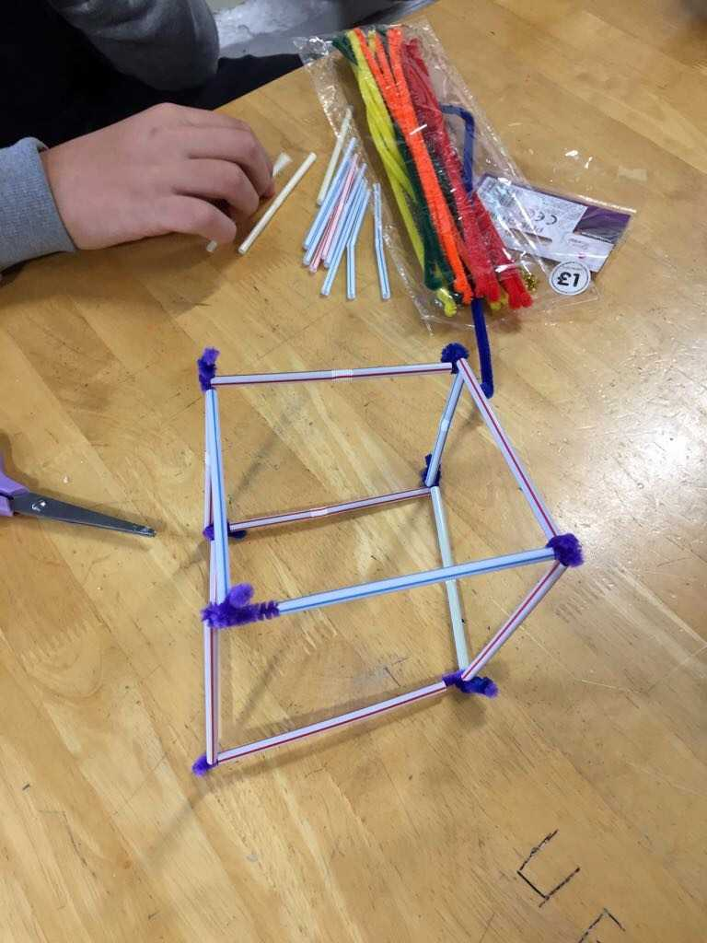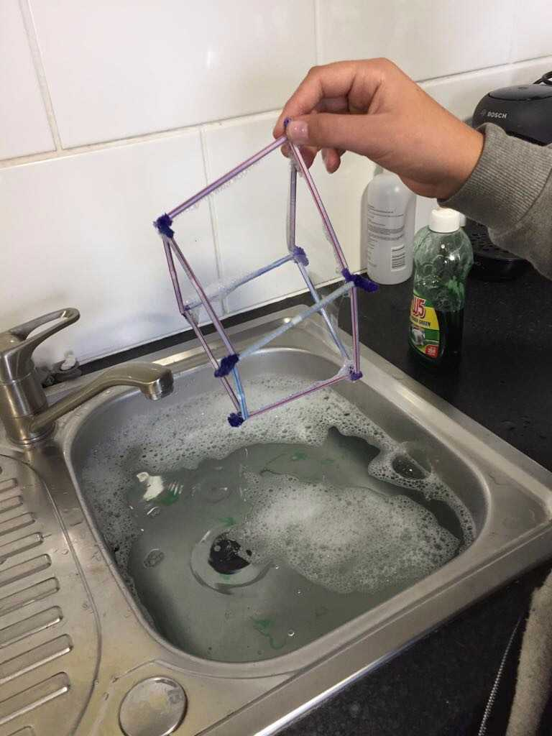
Teaseldown have been spending lunchtimes creating structures out of straws to create bubbles.
Creativity thrived whilst painting stones, which were then hidden around the Braintree area.
This is part of a new craze on Facebook, called "love on the rocks". The objective is to paint and hide your rock or stone and then hopefully someone will find it, post the picture on the love on the rocks Facebook page and then re hide it, it’s exciting to think just where a painted stone could end up!
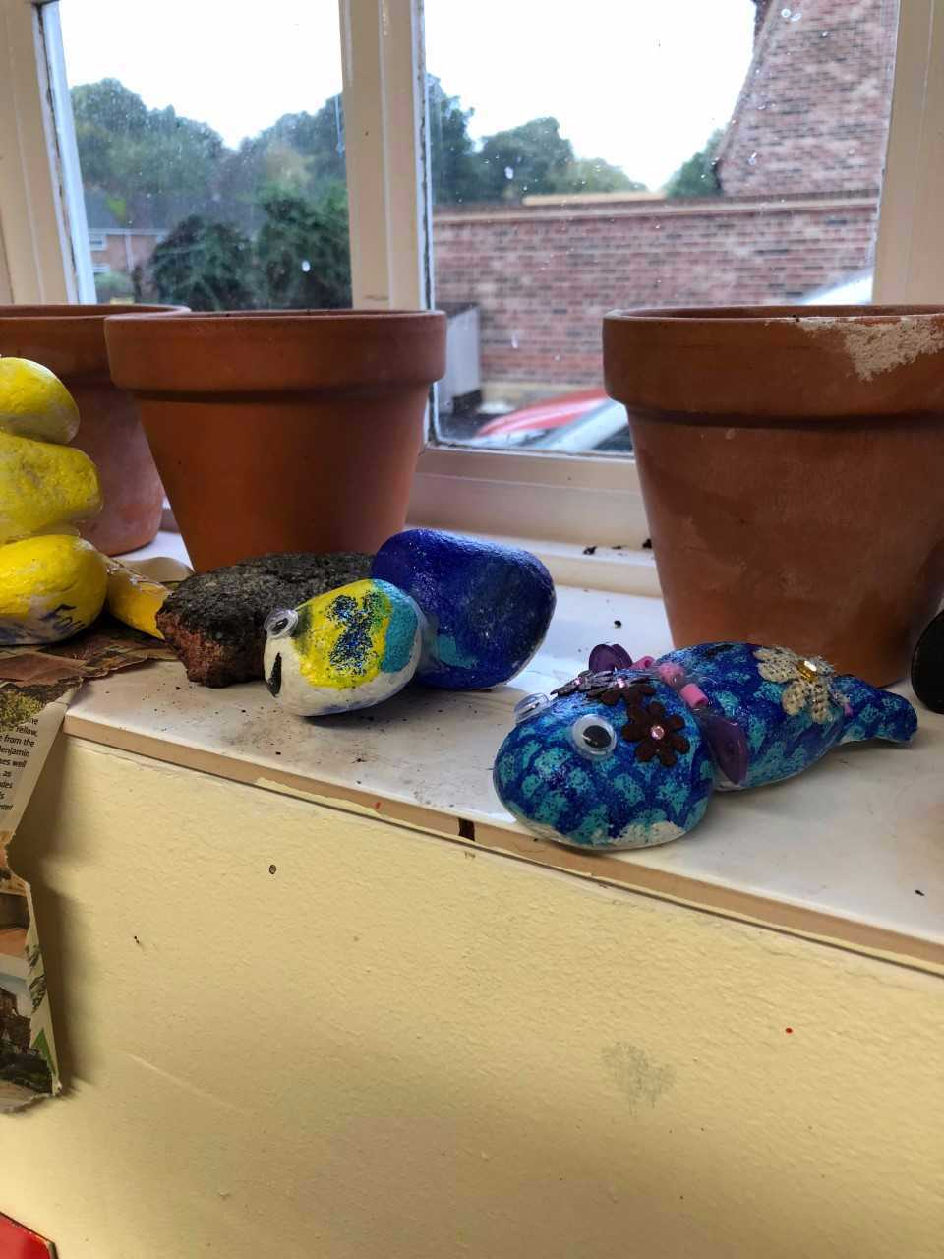

Two Teaseldown students recently earned certificates in either customer service or land-based studies as well, which is a great thing to start a C.V.
Sible Hedingham are also our home of BTEC level 2 Agriculture for the schools, as we are now a
Which is fabulous for GCSE alternatives in the future.
We may add more BTEC’s in the future, this may be an option for other students.

Welcomes/Farewells
Brook View and Teaseldown has welcomed a lot of new recruits recently.
Sammy and Debbie joined Brook View as assistant student mentors along with student mentor Roisin.
Chelsea and Tracy also joined Teaseldown as assistant student mentors before the summer holidays.
Tracy and Roisin wrote a bit about themselves before my colleagues on the website added them in.
One point to me!
I'm Tracy but prefer Trace!!
My previous experience in working with children was mainly on a volunteer basis as a football manager and then coaching netball for my local primary school.
I started in May 2017, and have loved getting to know all the students and building relationships with everybody.
I would hope to work with the therapeutic team in future and look forward to helping to make a difference in the lives of these amazing children.

Roisin graduated with a degree in English Lit from the University of Manchester in June this year. She also has a variety of experience working with young people with additional needs, so a role with Exceptional Ideas Ltd, seemed like a good fit! She also enjoys the fact that every day is different.
A welcome back to Emma R from Brook View, who returns part- time after maternity leave.
Anne joined our Outreach team based at in Black Notley, Braintree as planned.
She has previous experience in this area.
Jess (previously at Teaseldown) has returned to Exceptional Ideas employment and is working within the Outreach team.
Both Primrose Hill and Brook View have had changes to responsibilities, due to staff promotions and departures recently.
Nic, Jo and Claire have taken on activity co-ordinator, health and safety officer and transition co-ordinator roles at Primrose Hill along with…
Emma B (Fire marshal- Brook View)
Zoe (Induction co-ordinator -Brook View)
Becky (First Aider- Brook View)
Genni becomes Brook View’s new operational senior, after a recent promotion.
We hope she enjoys this role, keeping all the mental mentors in check at Brook View.
The students become rational in the end, as for everyone else…?

We recently wished student mentor Tiff and senior student mentor Stuart(Stu) a goodbye, as they took new roles away from Brook View.
They both were a key part of our schools, as are all the mentors and hopefully our new recruits to replace them will fit in as well as they did.

It’s rare we wish goodbye to students in this section, but one has begun a new adventure in Year 11 and beyond in the land of leprechauns and Irish stew, the Republic of Ireland!
Leaving with a solid GCSE and coping well in their new environment.

Good luck for the future. (Ádh mór don todhchaí in Irish!)

Nerdy Nora’s Newsletter Nugget
Near Sugar Loaves lives a weird old girl, who has an IQ of loads;
and clothes of a fragrant lavender smell.
Exceptionally elegant if a little tired and feeble, she’s married to a fine bloke who is mad about weasels.
Degrees in History, Science, Pop Culture and more.
Her facts are educational, even if she’s a little bit of a bore.
Nerdy Nora’s nugget this month is:
“About one new word is added to the English language every two hours!”

Don’t like facts, just ignora.
She’ll get the message one day…

This month’s best before was from prior to the summer holidays.
Our schools went kayaking at the Harlow outdoor pursuits centre.

Jo a mentor from Primrose Hill, had a swimming grass snake in her boat one week which caused some problems.

All the students received a level 3 paddle passport after completing the activity.
Well done everyone, hopefully the grass snake has learnt from these misnakes, such as messing with our student mentors!

The
This newsletter will be published whilst anti-bullying week is getting underway.
Exceptional Ideas don’t tolerate this in any way, shape or form and with many of our students having experienced bullying or associated behaviours we are very aware of its harmful effects on self-esteem, confidence and mental health.
If you think anyone is being bullied, including yourself be sure to seek advice from a responsible adult you trust so they can advise you what to do next.
Check out the charities Anti Bullying Alliance, Ditch the Label and the NSPCC for resources, information, videos to find out more.
Back to The Newsture
Everything needs a freshen-up from time to time.
Stay tuned for a brand-new staff interview feature coming in the December issue and beyond.
Putting them on the spot with some thought-provoking open questions, all set by me!
Coming soon…

Any Ideas?
For our schools, the website or for this student newsletter?
Contact us using our website feedback page, or get in touch through social media, active on:

(students must NOT follow staff on social media for Child Protection, E-Safety reasons)
That was the news, Goodbye!
The Editor

