  
Student Newsletter

ISSUE 1: November 2016

Website: www.exceptionalideasltd.co.uk

School office phone: 01787 469 373

E-mail: admin@exceptional-ideas.co.uk

Hello everybody and thank you for clicking on our student newsletter page! A brand-new idea from the exceptional minds across our schools. This is the first issue of an online newsletter where we will keep students, staff, parents and site visitors across the web updated with fun stuff, general information, student work, staff news and recruitment opportunities for any aspiring staff members, who fancy becoming (mental) student mentors!



our top story is from our original school, Teaseldown.

Casey in Year 10 worked very hard in the weekly STEAM challenge on this amazing sign for the newly painted school shed. The artwork speaks for itself!

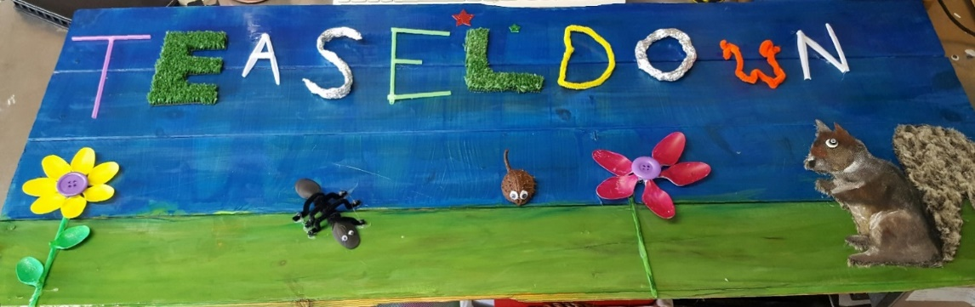

It brightens up Teaseldown, and Van Gogh would surely be proud of it!

The staff and students at Teaseldown school had a weekly STEAM challenge set,to make things for the garden without growing anything. Everyone has been involved in making things, such as bees, ants and butterflies and there have also been lots of painting the shed. The picture below showed all there painting knowhow had come to fruition.

Take a sneaky peek below at the shed:

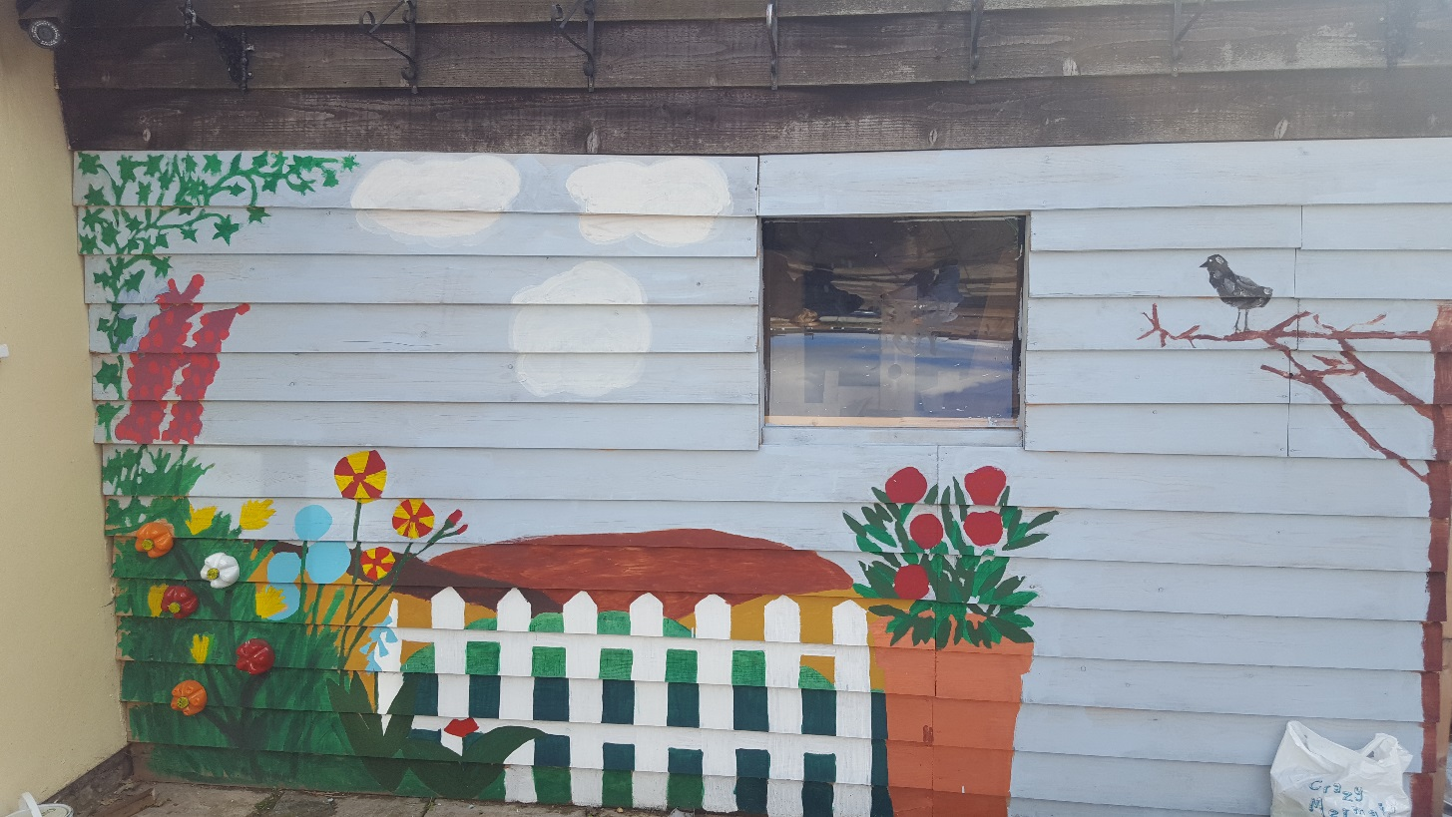

Activity changes

Many of you may be aware already, but our traditional Wednesday and/or Friday afternoon activities changed, beginning a new year with new ideas.

Last half-term they were: Volleyball, (Monday)Karate, (Tuesday) Nintendo Wii, (Wednesday)Netflix(Thursday) and Woodwork(Friday).

The activities were a great success! Students and mentors learnt new skills and met people who they have become friendly with.

It was a great way to let our hard-working mentors join-in and have fun also, whilst getting to know there work colleagues and students from other schools better than ever before.

The Editor, as well as many others, believe it’s been so much more beneficial educationally and therapeutically than our previous activities, which became quite repetitive.

Our activity team are busy planning future activities as I write.

I can confirm, most students would have chosen two (KS3) or one (KS4) activity(ies)with a back-up option for this half-term. In case there is ever a cancellation/lack of attendance at any of the following activities:

Indoor-Climbing

Ice Skating

Bake-off

Ceramics

Game Design

Drama

Well-Done Zone

Celebrating student’s achievements

Big congrats to PMB, ODP and JoCH who passed their assessments in Karate. Achieving their white with a red stripe belts. They all passed with an A which is the highest grade possible! Over the 6 weeks previously they learnt the different: kicks, punches, blocks and a Kata!

The sessions were held at Braintree Martial Arts Centre.

TH, a student from Teaseldown School, has been doing his work experience and has enjoyed it. He hopes it will lead to an apprenticeship. Great for your C.V. TH. To apprenticeships and beyond I say!

Charity Corner

So much important work is undertaken by charities that need your support. Our staff and students have done there bit this half-term. Can you?...

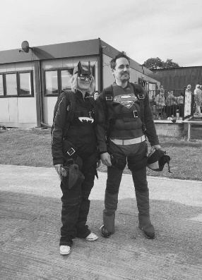

Nicola (Nic) Student Mentor from Primrose Hill School and her Senior Student Mentor Michael (Mike) had great fun on Saturday 24th September with a superhero skydive for The J’s Hospice. This charity provides much-needed hospice and respite care services to young adults aged 16-40 who are living with life limiting and life threatening conditions including cancer, Duchenne muscular dystrophy, Juvenile Huntington's disease, cystic fibrosis and many more. These are complex conditions that, in most cases, will lead to the young adult experiencing severe disability.

They raised an incredible 900 pounds for this worthy cause, superb job! They’ll start believing they can fly soon, honest!

JC surprised everyone when he presented his GCSE Citizenship Coursework across the three schools, with much praise on the last two days of half-term. The Coursework was to do with Mushroom Theatre Company (MTC)/ Equal People Performing Arts(EPPA).



A theatre group and charity based in Rayleigh, Essex providing dance, drama, singing, yoga, life skills and venue hire for community groups and additional needs of all ages and abilities. Normal people (Whatever normal is!) mix inclusively with this group and everyone joins together to experience the many social, therapeutic and general health benefits that performing arts brings.

The feedback from JC’s presentation and live vocal demonstration seemed overwhelmingly positive.

Here’s just a few of the reactions…

you touched many people today.

Well done, your presentation was outstanding. Brett (Therapeutic Director)

Your voice - what can we say? - just amazing.

Keep up all the good/hard work - well done. Paula and Hannah N (Administrators)

I thought it was very good. You did very well keeping your nerves most of the time. I think you were talented and very good at singing.ES

Positivity keeps on coming, JC’s been invited to perform at his local Christmas light switch-on also!

Keep smiling and singing.

ES didn’t just provide feedback on JC’s singing.

ES and family completed a 20-kilometre Cycle for Life, and along with over 700 cyclists, raised a phenomenal £68,000! Mid Essex charity Farleigh Hospice, which per their mission statement:” exists to meet the needs of local people affected by life limiting illnesses and to support those who have been bereaved” Farleigh Hospice would be very proud of ES, as is everyone else.

Well done!

Displays

whenever we show students, parents or professionals around our schools, you can’t help but notice some superb pieces of work on our walls. This year a mentor at each of our schools have been given the new role of Display Designer so our displays look even more organised, colourful, eye-catching and receive much-needed TLC. The care of our displays is a top priority.

 It’s a shame student care comes second!

(Just a joke, don’t panic prospective parents!)

Notice Board

To Primrose Hill School Student Mentor Laurence, (Laz)as he becomes our new Computer Science and Music Co-ordinator. As well as Brook View School Student Mentor Christine who becomes Senior of Training and Post-16. They both seem to be enjoying their new roles and it’s a credit to their hard work a promotion has come both of their ways.

Three Student Mentors from Teaseldown School (Jess, Jake and Neil) have left us at the end-of last half-term for new roles. We all wish then good luck in their new jobs and thank them for all their good work over the years. They’d be welcome back anytime, until someone takes your jobs!

Nadine, also from Teaseldown, has taken Maternity leave, following the birth of her little girl but will be back at Teaseldown next year.

Dates for trips/visits or events will be coming soon across our schools. Watch this space!

Welcomes

I’ll let Brett Runchman (Therapeutic Director) take over this story and introduce some new mentors to you all.

We offer a warm welcome to Zoe. (At Brook View as Student Mentor) Sam (Student Mentor - Teaseldown) and Fiona (Student Mentor across all three Schools).

Good luck getting to know all the students and staff, it will be a rollercoaster ride, but worth it!

Two schools, One vision-A recruitment mission!

Join our exceptional team with AMAZING ideas at Teaseldown and Brook View schools!

Help students aged 11-17 overcome barriers and achieve success

There is one full-time Position as Student Mentor/ Assistant Student Mentor available at the two schools, and possibly part-time/voluntary opportunities across our schools also.

Find out more on our Facebook page, or at exceptionalideasltd.co.uk/now-hiring to see more. (Thankfully, writing cringey Queen based Sub-headings is not part of the job!)

The Boring Stuff-ish

Teaseldown have a new-old school car which Gina says, “the students are very excited about”.

Brook View School gave this newsletter no stories and missed the publication deadline as we went to press. Try again next- time, silly sausages!

#Nonewsisgoodnews?

Any Ideas?

For our schools or for the brand-new student newsletter?

Pass on to Student Mentors or get in touch through social media, active on:



(students must NOT follow staff on social media for Child Protection, E-Safety reasons)

That was the news, Goodbye!

The Editor

(JC Year 11 Primrose Hill School)