Student Newsletter

ISSUE 4: July 2017

Website: www.exceptionalideasltd.co.uk

School office phone: 01787 469 373

E-mail: [admin@exceptional-ideas.co.uk](mailto:admin@exceptional-ideas.co.uk)

Hello,

after a very long hiatus; this newsletter returns as of July and beyond. It’s set to get more regular, even as I’ve left Primrose Hill to start College in September.

My new, challenging but fun role as Newsletter Editor has just begun.

I’m so excited to work alongside some fab staff and students, whilst promoting the school’s work and ethos to a new audience.

Enjoy!

(Congratulations to Primrose Hill for being the first school to send some info over for the newsletter, YOU WIN!



NOTHING AT ALL…



“Good” Rating

A positive inspection from these ever-so slightly scary people on the 9th May left us pleased, when our report was published on June 20th.

Inspectors praised our education ethos, describing it as “literally life-changing for some pupils and their families.

“ Leaders have created an environment where ‘everybody learns together’ and they promote learning by supporting staff to advance academically alongside pupils.

Our glowing report doesn’t end there…

“Staff are patient and meticulous in meeting pupils needs. Inspectors saw clear evidence of pupils progress in their social skills and personal development.”

This proves our care and quality of education may match and even surpass a local mainstream for SEN pupils in my totally non-biased view. ;)

Our numbers of staff and students continue to grow.

The challenges students overcome and the work staff do to learn and train in their roles, allows us to achieve, pardon the pun, exceptional things!

On- behalf of all the students, the staff deserve a HUGE thank you for making this school so unique and a fun place to learn in.

If you wish to see our report in-full and learn more about the vital role OFSTED does to monitor education, health and social services please visit,

https://www.gov.uk/government/organisations/ofsted

and follow the links provided.

Year 11 Exams



Across May and June Year 11 students were subject to the annual-

wonderfulness of exams!

Year 10 students took GCSE’S in Citizenship and/or Food Technology whilst Year 11’s had an intense period of Revision and sitting of multiple exams across four weeks which included a much-needed half-term break.

The atmosphere was rather different to the Mocks, with a fair amount of Revision/Chilling going on but…

People knew it was the real thing and all of us tried our very best and spent lots of times being cookie monsters and cooking/eating sweet treats!

We were pretty cream- crackered after it was all finished, and so were the staff.

They were very supportive and encouraging all-the way through so deserve a virtual-round-of applause!

Teaseldown were subject to hot, cramped conditions in the hall throughout their STEAM weeks but were saved by EIPCA (Exceptional Ideas Protection of Cruelty to Autism and ADHD)

after the exams were finished!!!



Be sure to collect your GCSE Results from Teaseldown on the **Thursday 24th August** **from 10am-12pm.**

Those that are heading off to college in September, ensure you take the certificates and everything else you need to ensure the enrolment process runs smoothly for your chosen course.

Exam results are published on our website and in the next issue of the Newsletter so stay tuned to be Generally Content and Slightly Ecstatic everyone, with the school results overall!

STEAM Weeks and News

Exceptional Ideas recently acquired an Outreach office based in Black Notley, Braintree that our mentors from the Senior and Outreach teams can work out of.

Perfect for writing reports, conducting interviews with new staff like me and also providing a safe space for a student to work on Outreach if needed.

It’s main feature is the lovely wide window that let’s all the natural light in upstairs. This keeps our open plan- meeting room cosy and warm.

The Senior team tried it out soon after it opened, take a look for yourself…

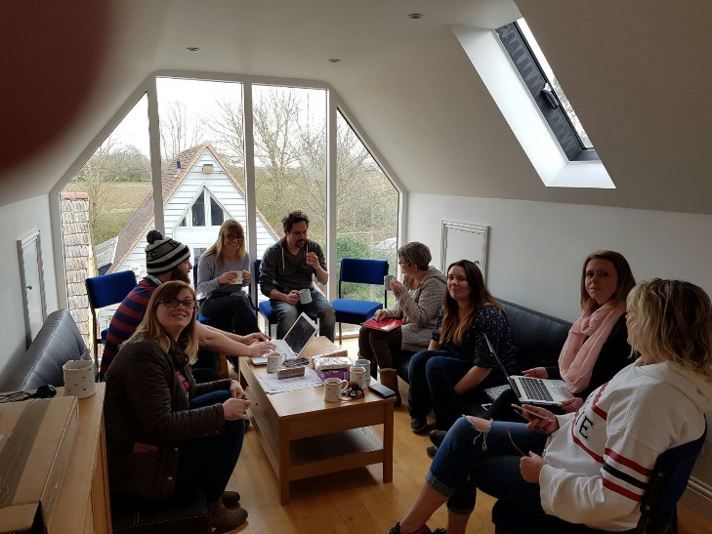



We also had a visit in April from leading autistic speaker and campaigner Dean Beadle.

His insights, views and story of his life with Asperger’s were fascinating. The audience made up of staff, students and the local community really enjoyed his talk and we hope he will come back again next year.



As part of our STEAM weeks during exams many of our students and staff went to MCM Comic-Con at the Excel, London.

A variety of comic characters, media working across TV, film and theatre attended.

Special guests included award- winning comic Catherine Tate and acting- superstar Billie Piper.

Star Wars nuts from Primrose Hill, Mike(Senior Student Mentor) and student Josh sent this lovely photo of them joining the ranks of the First Order as stormtroopers.

“You may fire when ready.”

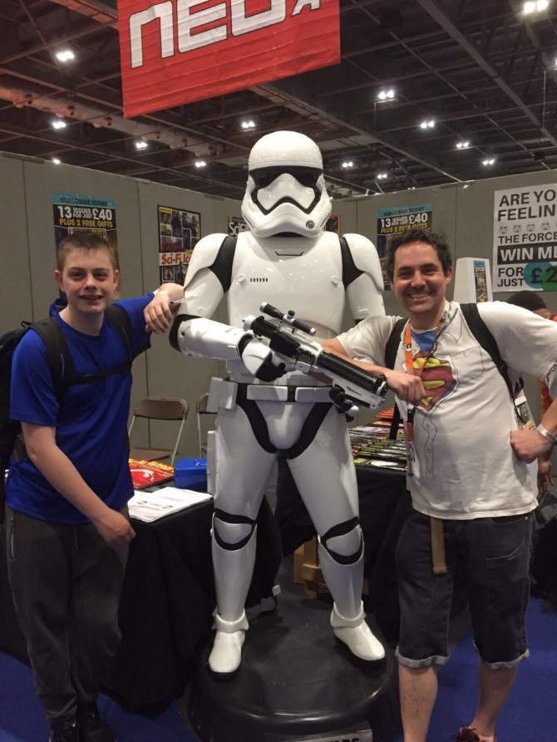

During STEAM, the schools also went to the beach and had a good time at the seaside exploring the beach and having those classic seafront treats!

One of our students was getting busy drawing in the sand…

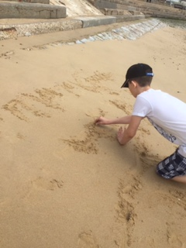

Other events across the weeks included Den-Building and climbing up a very tall wind turbine in Swanage, Dorset.

Stay tuned for more STEAM weeks in September and beyond…

A fellow Josh at Teaseldown can be pleased with himself as a photography class allowed him to take these stunning images demonstrating texture.



UT from Teaseldown upcycled some tired furniture as part of our ASDAN course, the mentors love it.

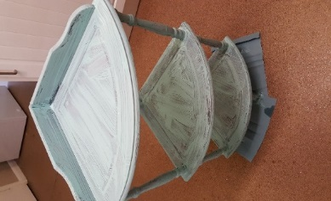 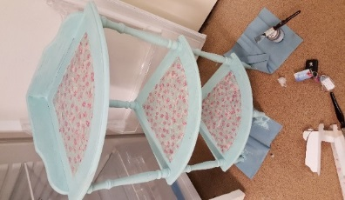

Jake from Brook View took on a giant Pringle ring challenge.

I would have loved to try this out, but as they say once you pop, the fun don’t stop!

I hope whoever ate the Pringles afterwards they enjoyed them as much as I would …

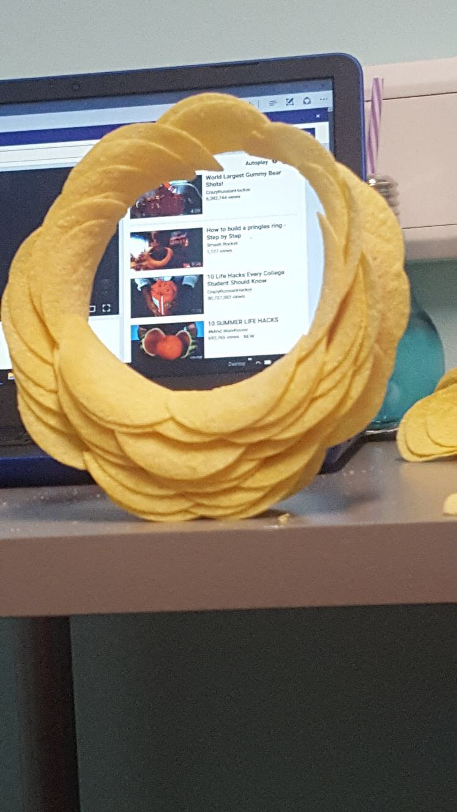

At a time when most of Year 11’s are weighing up their preferred College, I thought it was fitting to include this eye-catching Transition wall display at Brook View.

Judging by the level of planes, I’ll leave air traffic controlling to the pro’s.

“Chock’s away to Page 9!”

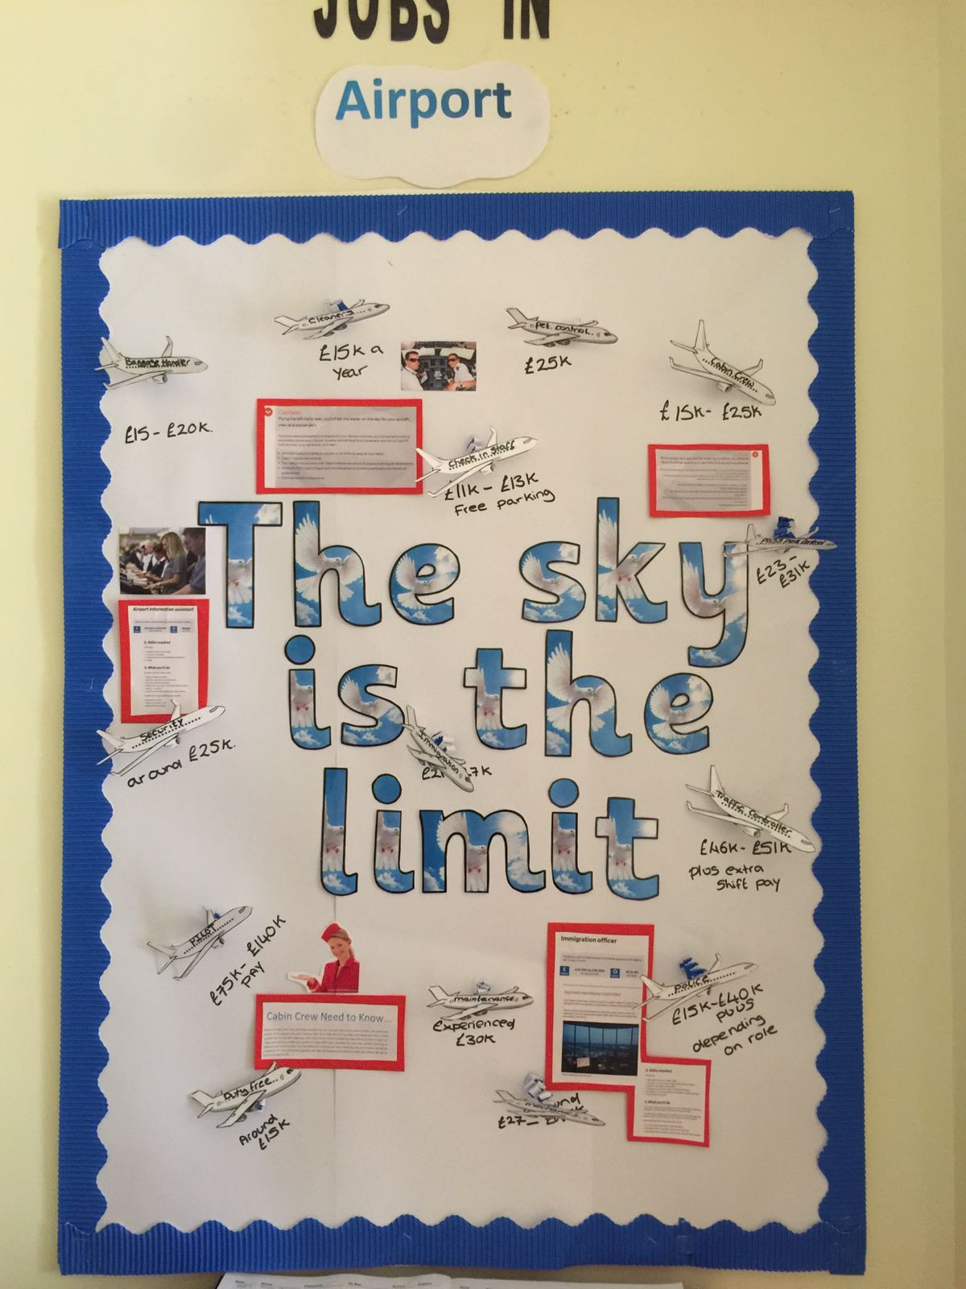

Someone with a love of Lego at Teaseldown took on a DT/Computer Science project to create a life-size robot.

How epic is this friend from the future?

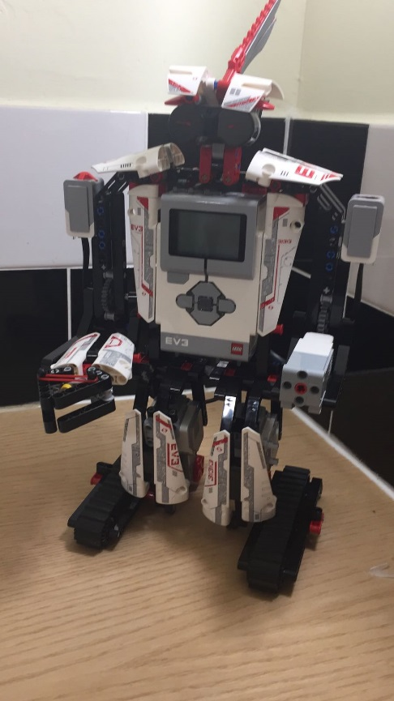

Circle construction farm allowed a student at Brook View to shine and develop more interests.

Good on you for getting creative!

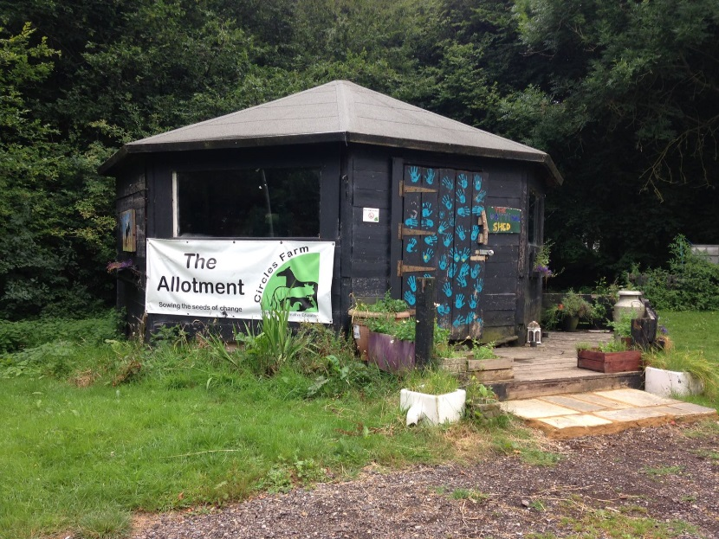

This month’s best before work focusses on Casey at Teaseldown, who created an impressive fact-file in English on the Titanic near its 105th Anniversary of “sinking the unsinkable” in April.



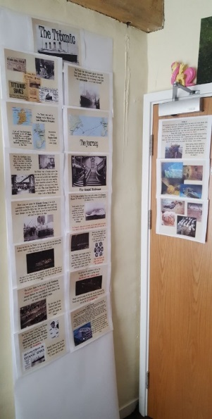

Welcomes and Farewells

A big congratulations to veteran mentors Mel and Lucy from Primrose Hill.

They have taken new roles from this month, with Mel in our newly created position as Senior Student Mentor for Data Management and Lucy as Curriculum Planning Coordinator.

Working across all three schools, Mel will be tracking our data and keeping on top of curriculum levels.

Lucy will be responsible for making new lesson plans fun and exciting,

If she doesn’t do a good job in this, you’ll now know who to moan at now…

I hope you both enjoy the new roles and with Lucy returning full-time for the company after two years working part time after maternity leave, we gain a valued staff member all to ourselves!

Many staff have joined us and/or taken on new responsibilities recently.

The Outreach team are being set up to expand our provision and I will give more info on all of this in the September issue ,as it would be too much of a squeeze to include it all now.

Please apply online if you’re looking to be the next mentors for us, helping students overcome barriers and achieve success.

Take a peek at this link and be sure to read the job descriptions on the website before you apply to any new role.

Please don’t slip on Brett’s banana car on the way to interview though, keep those eyes peeled!

http://exceptionalideasltd.co.uk/now-hiring/



Kirsten at Brook View and Linda at Teaseldown left us recently, leaving Deputy Exam Officer and Transition co-ordinator roles to be taken on by existing staff members.

We thank them for all the work they have done but they will forever be known as traitors to the students for jumping off to somewhere new, not staying at our schools!

Charity Corner

One of our Primrose Hill mentors Nic was set to take on another daring challenge(Wing-walking) in aid of the J’s Hospice recently!



Raising funds for the clinical team so they can continue to deliver the amazing home care and services to all of their young adult patients aged 16-40 with life limiting conditions and terminally ill.

The J"s Hospice are very close to Nic’s heart, as she lost a close family member last year and this is her way of giving back to the J's so they help and support other people like they did for her family.

**Unfortunately, this was rescheduled due to bad weather.**

**Watch this space for an update on this story in our September issue!**

 

Jordan C still attends Mushroom Theatre and remains busy with lessons and performances at events both now and in the future.

He was very pleased to win a Special Commendation for Singing and received a certificate, engraved candle and a lot of claps from fellow mushroomers!

This Newsletter wants to wish you a healthy and happy Summer Holiday full of as much fun as possible.

See you all back on **Wednesday 6th** **September!**



Any Ideas?

For our schools or for this student newsletter?

Pass on to Student Mentors or get in touch through social media, active on:



(students must NOT follow staff on social media for Child Protection, E-Safety reasons)

That was the news, Goodbye!

The Editor