Teamwork @ Teaseldown between Shannon And Joel means students know where to put their christnas cards:
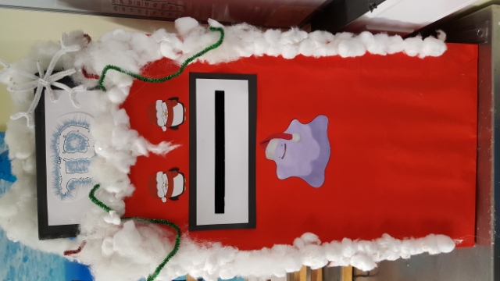
Primrose Hill Mentor’s PREVENT training came in handy when an unattended bag was left unaccompanied on a train from Liverpool St to Chelmsford this month.
Primrose Hill students and mentors had an interesting day visiting the Tate Modern, seeing London Southbank’s landmarks in the process, and they thought the drama of the day was over…
Thankfully, an off-duty police officer from the Met dealt with the situation superbly and after giving a stern telling off to the member of the public who left the bag, allowed us to continue our journey without an explosive end.
Exceptional job Officer Plod!
(We don’t know the real name. Some say the Stig is less mysterious…)

Well Done-Zone
Celebrating Student achievements!
Our star student of this issue is Josh KK from Primrose Hill, becoming a black belt in Ju-Jitsu and winning two gold medals in the same week!
This Martial Arts master is only 14 years old and I had the oppurtunity to learn more about his acheivements when I interviewed him recently:
JC: This newsletter heard that you gained a black-belt in Ju-Jitsu.
How did you get into it, and what is it?(Ju-Jitsu)
JKK: It’s an old form of Japanese martial art, mainly for self defence.
I first got into it through an old school mate in Year 3 who encouraged me to try it out, the Sensei(Martial arts teacher) has remained the same since and after starting off with the basics, I got my gee(uniform) a couple of weeks later.
JC: Having done this for a long time what did you have to do to progress up the ranks to black-belt?
JKK: I kept with it, it was something I knew I wanted to do, telling myself I’m good at this and I can do it, getting the black belt in the end after about six years of training!
JC: At the weekend, you took the grading, How did you the achieve the black belt?
JKK: There’s a syllabus which is six-page sheet full of moves, punches and strikes on it.
Each page had about 30-40 different movements all in 3-4 sets. I also completed a verbal and full body anatomy test.
After a warm-up and a practice,
We put our names down on a sheet to be marked which only happens when you’re entered into a black belt grading.
I was very tired afterwards and full of bruises.
My Sensei explained that if you didn’t have bruises there is something phycially wrong with you!
Good that I was hydrated though, as that would have made me more tired.
JC: Well done Josh, it sounds great that you achieved it- the black belt!
JKK: It was great fun, touchwood I don’t exhaust myself to death
in my next fitness test.
The next grading needs a fitness test, with running up and down and throwing people included, for 30-45 minutes.
It will be full of challenging stamina work.
JC: we’re almost out of time Josh, but what about the medals, how do you feel after achieving that too in the same week?
JKK: I was nervous and in pain from my grading, but had some competition that wasn’t too hard as their belt grading was much lower.
JC: Thanks for the interview Josh.
JKK: No worries!
Congrats to JC who recently passed his Level 2 Food Hygeine for Catering and Health and Safety in the Workplace.
The online courses covered risk assessment, food temperature control, hygeine,manual handling,RIDDOR and more…
JC also got busy with yet another performance for Mushroom Theatre Company this November.
Michael Jones (Primrose Hill Senior Student Mentor) takes over the story with a show review:

On Sunday the 20th of November, Brett Runchman and I had the rare opportunity to go and see one of our own, perform at the Towngate theatre in Basildon.
JC, a year eleven student at Primrose Hill School who is also part of Mushroom Theatre Company was performing as a solo singer in their cabaret show “Sunshine In My Pocket”.
The group is a mixed bag of talented youngsters from across the county ranging from those with very challenging needs to those with no diagnosis at all.
I have seen a lot of young people’s theatre in my time as my wife runs her own youth theatre company and I have to tell you the standard was incredibly high.
Jordan sang a very demanding song by Adele and pulled it off with an audience pleasing high tenor voice that resonated round the rafters in perfect pitch.
Later on in act two, he was also part of a drama piece about the follies of social media and an acapella piece from NBC musical show Smash (Broadway Here I Come) which was very smooth and slick.
Some other notable high points in the evening included an entire cast rendition of Can’t Stop The Feeling by Justin Timberlake with the one hundred plus strong cast dancing and singing with a huge amount of joy that came flooding off the stage.
As well as a brilliantly moving dance piece to a cover version of Simon and Garfunkel’s The Sound Of Silence by Disturbed.
All in all Brett and I had a great evening and we would strongly recommend anyone who gets the chance to go along to another Mushroom show.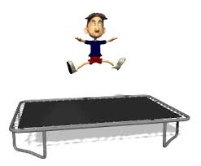
Jake From Brook View School has been attending Bounceability,Colchester for a while and has achieved a level 8 in British Gymnastics trampolining.
He has received a certificate for this and a badge.

Well done to Callum (Teaseldown) who completed his work experience at Polyspiral in Sudbury, Suffolk a leading graphic design buisiness.
He created his own website and I had a sneak peek at the website in development, it was very informative and professional.
Curriculm Corner Ofqual are the examination board who oversee all GCSEs in the UK. They are bringing in a new system where they are beginning to phase out the grading system of A* to G and bringing in a new system of 1-9.
The school(s) wish to tell everyone that our Year 11’S will receive normal A*-G grades in all subjects apart from English Language, English Literature and Maths.
Grade 5 is considered a good pass ,with grade 9 being the highest and set above the current A*. The new system is intended to help provide more differentiation, especially among higher achieving students.
The grades will be given for the first time in 2017 exam results, for subject
specifications that first started teaching in 2015. By 2019, all GCSE results will be using the new system.
(Thankyou to Jenny, Senior Student Mentor for Assessment/ quality control for bringing this story to the newsletters attention.)
Casey has started a brand new GCSE in Health and Social Care and is loving every lesson. This lesson is now added to the curriculum ,available for all students at Exceptional Idea

